**Assessment Activity Review**

**Introduction to Programming R/618/3658**

**Student Name:** Gokce Gercek

What went well with creating the game?

|  |
| --- |
| The tutorials were very helpful with creating the game. The commands are arranged in different colours (motion, variables, events, looks, sensing) which makes it easier to find your way around. The logic of the programme is similar to the non-graphic programs like using the “if statements”. The sprites, the backgrounds are very colourful which makes it easier to create a kids’ game. The sound library had all the interesting sounds I needed. |

What did not go so well with creating the game?

|  |
| --- |
| Placing the if blocks inside forever loops and placing operators were confusing at the beginning. Arranging the postion, the size and the interval of the sprites for easy use took time. |

How well did it meet the design brief?

|  |
| --- |
| I believe the game I created meets the second design brief as there is a witch who is catching magical items falling from the sky. It will be entertaining for the 6 years old child as she/he moves right and left on the screen and every time a potion is caught, the magical sound will encourage the child to catch more. The child will be rewarded with score and the cheering sound at the end showing with a new “you win!” background |

What improvements could you make to the game?

|  |
| --- |
| More effects could be added to the game:  The potions could be more colourful and when they are caught they could create a spark.  The potions that are not caught could break at the ground and make a mark  The witch could be talking during the game |

Student Signature: 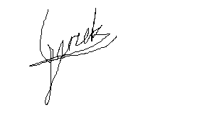

Date: 14.10.22

**End of Assessment Tasks**